Options.Verbose = true;

Options.nPoints = 500;

Options.Gamma = 2;

Options.Iterations = 400;

Options.Sigma1 = 1;

Options.Wline = 0.01;

Options.Wedge = 50;

Options.Wterm = 1.0;

Options.Sigma2 = 5;

Options.Mu = 0.2;

Options.GIterations = 600;

Options.Sigma3 = 2;

Options.Alpha = 1.0;

Options.Delta = -0.1;

Options.Beta = 0.5;

Options.Kappa = 4;

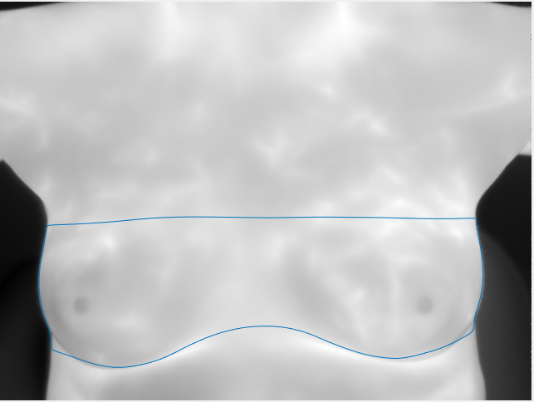

Options.Verbose = true;

Options.nPoints = 500;

Options.Gamma = 2;

Options.Iterations = 400;

Options.Sigma1 = 1;

Options.Wline = 0.01;

Options.Wedge = 50;

Options.Wterm = 1.0;

Options.Sigma2 = 20;

Options.Mu = 0.2;

Options.GIterations = 600;

Options.Sigma3 = 2;

Options.Alpha = 1.0;

Options.Delta = -0.1;

Options.Beta = 0.5;

Options.Kappa = 4;

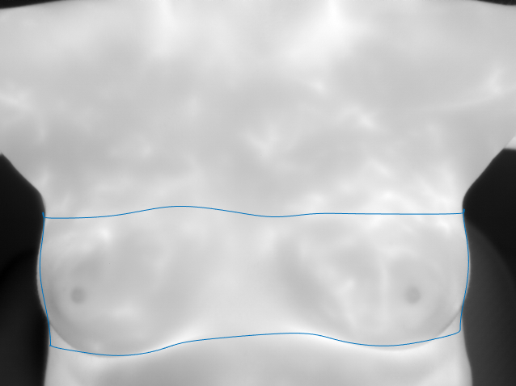

Options.Verbose = true;

Options.nPoints = 500;

Options.Gamma = 2;

Options.Iterations = 400;

Options.Sigma1 = 1;

Options.Wline = 0.01;

Options.Wedge = 50;

Options.Wterm = 1.0;

Options.Sigma2 = 5;

Options.Mu = 0.02;

Options.GIterations = 600;

Options.Sigma3 = 2;

Options.Alpha = 1.0;

Options.Delta = -0.1;

Options.Beta = 0.5;

Options.Kappa = 4;

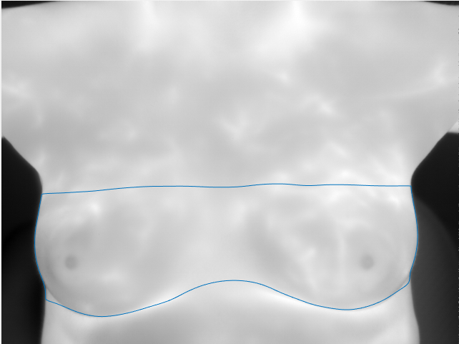

Options.Verbose = true;

Options.nPoints = 500;

Options.Gamma = 2;

Options.Iterations = 400;

Options.Sigma1 = 1;

Options.Wline = 0.01;

Options.Wedge = 50;

Options.Wterm = 1.0;

Options.Sigma2 = 5;

Options.Mu = 0.02;

Options.GIterations = 600;

Options.Sigma3 = 3;

Options.Alpha = 1.0;

Options.Delta = -0.1;

Options.Beta = 0.5;

Options.Kappa = 4;

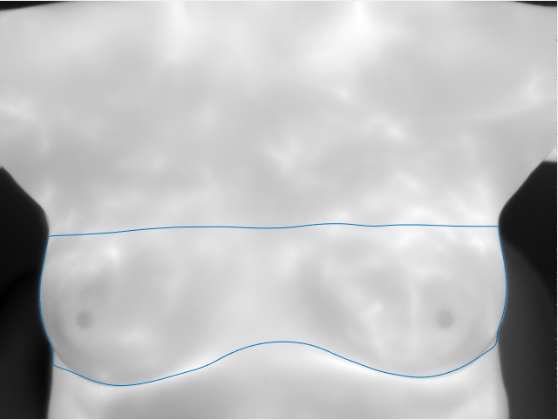

Options.Verbose = true;

Options.nPoints = 500;

Options.Gamma = 2;

Options.Iterations = 400;

Options.Sigma1 = 1;

Options.Wline = 0.01;

Options.Wedge = 50;

Options.Wterm = 1.0;

Options.Sigma2 = 5;

Options.Mu = 0.02;

Options.GIterations = 600;

Options.Sigma3 = 3;

Options.Alpha = 1.0;

Options.Beta = 0.5;

Options.Delta = -0.1;

Options.Kappa = 4;

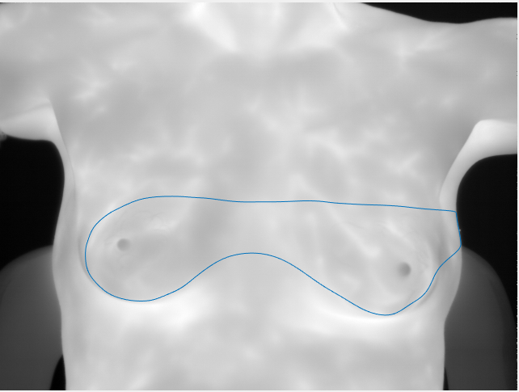

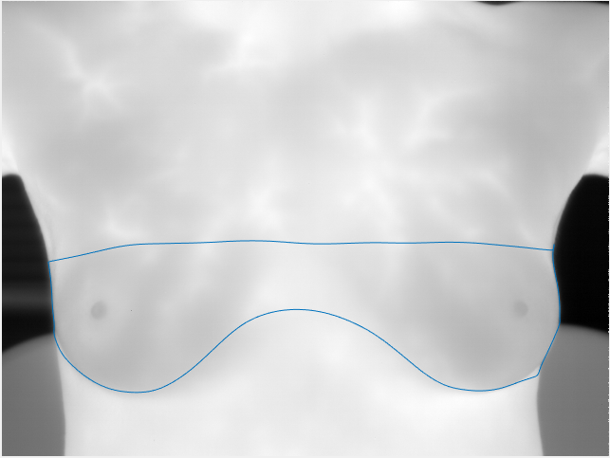

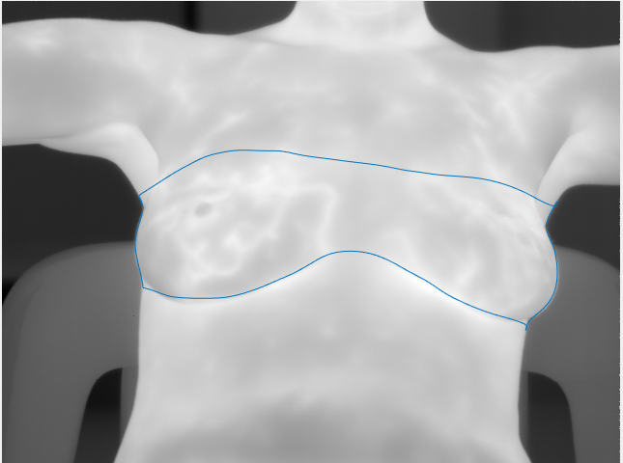

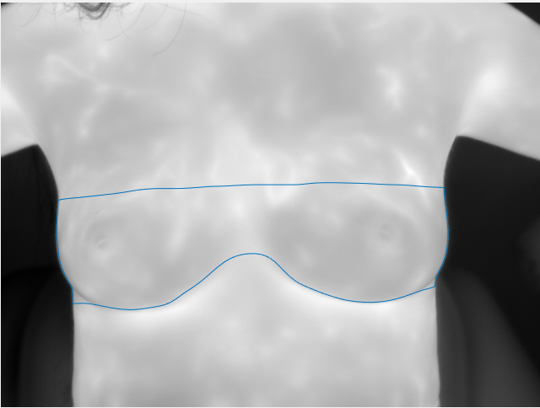

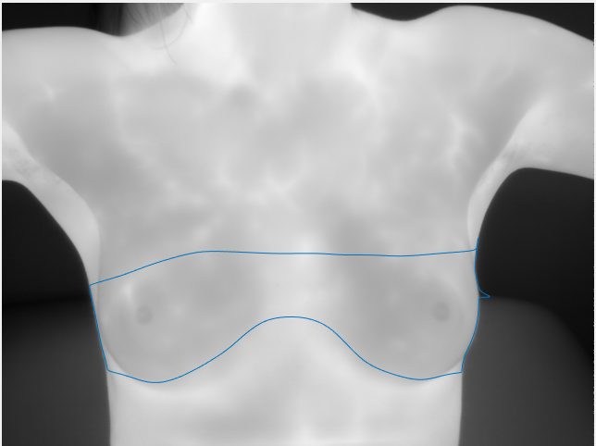

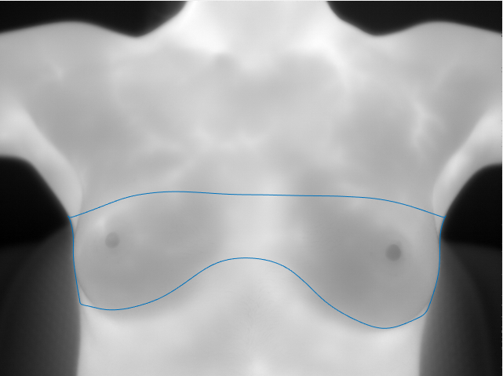

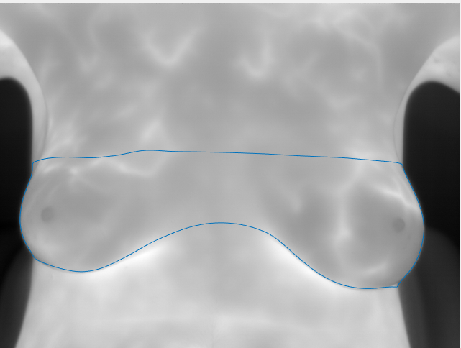

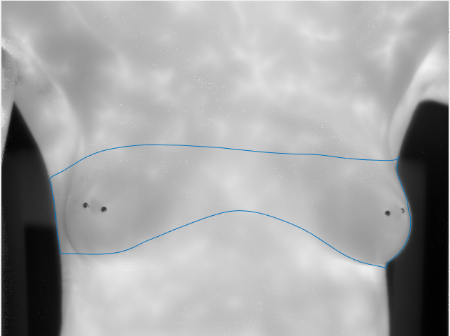

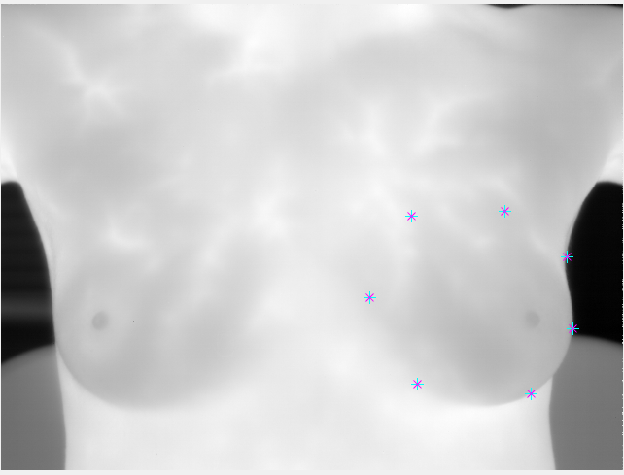

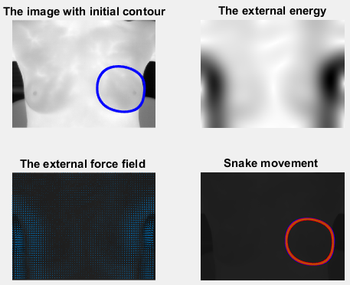

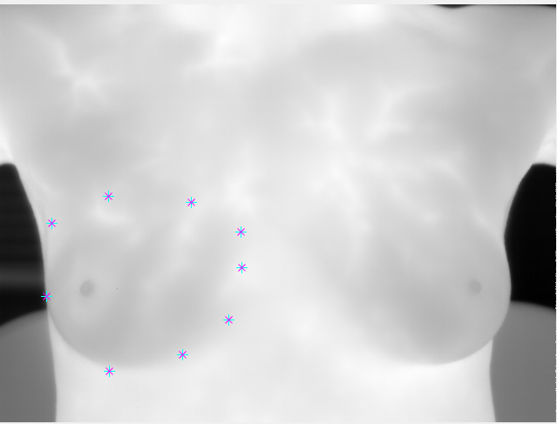

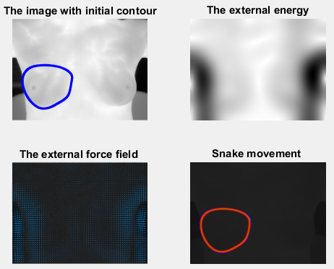

Sigma1 = 50

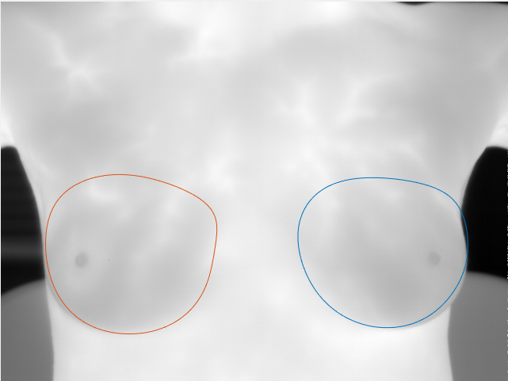

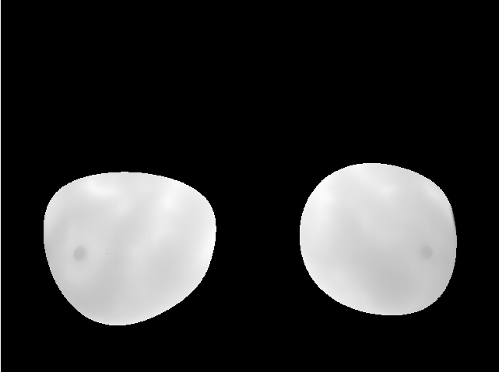

Sigma1 = 25

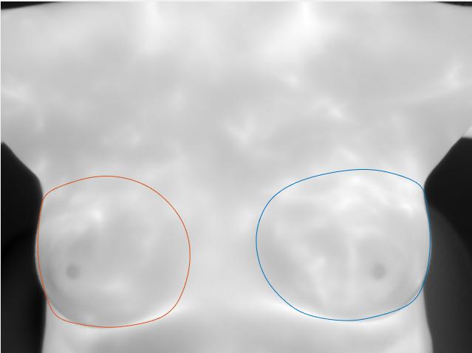

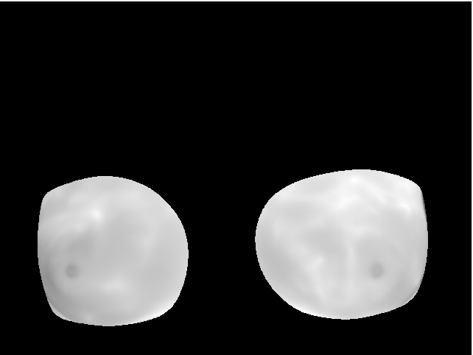

Sigma1 = 50

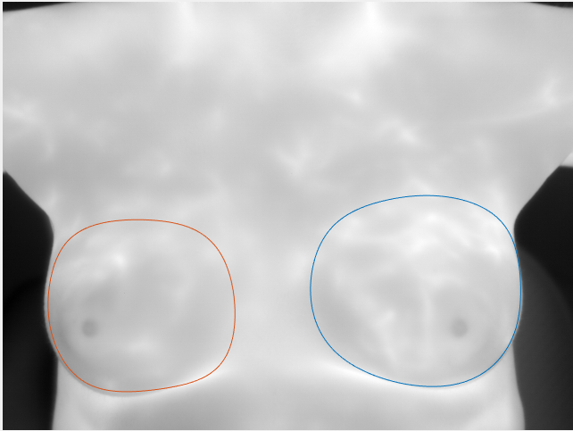

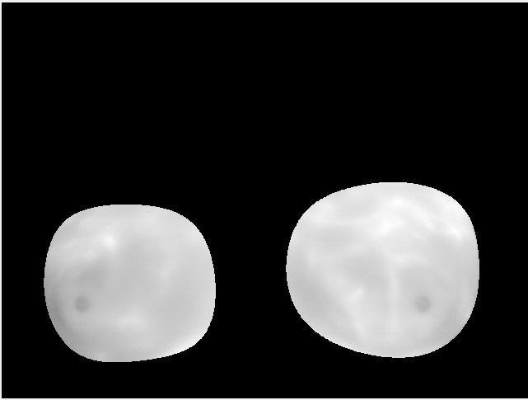

Sigma1 = 30

Wterm = 0.01

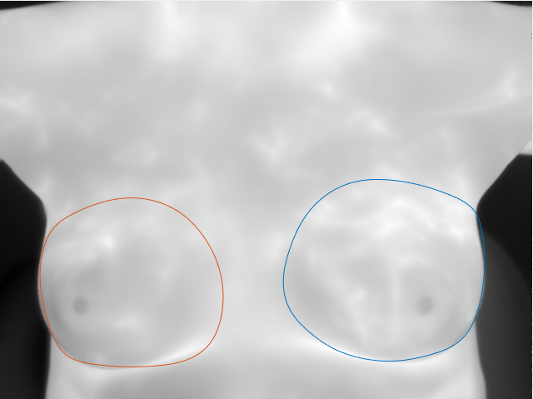

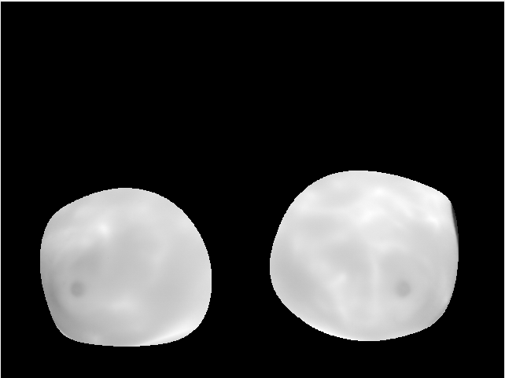

Sigma1 = 30

Wterm = 0.01

Wedge = 25

Not touching the edge. 9 points

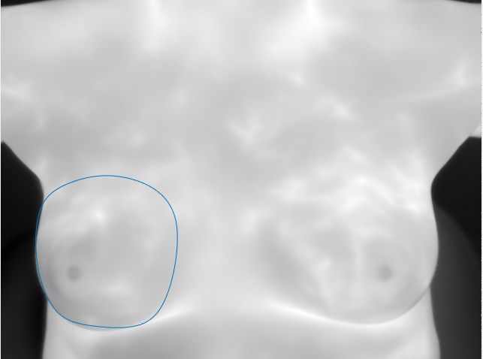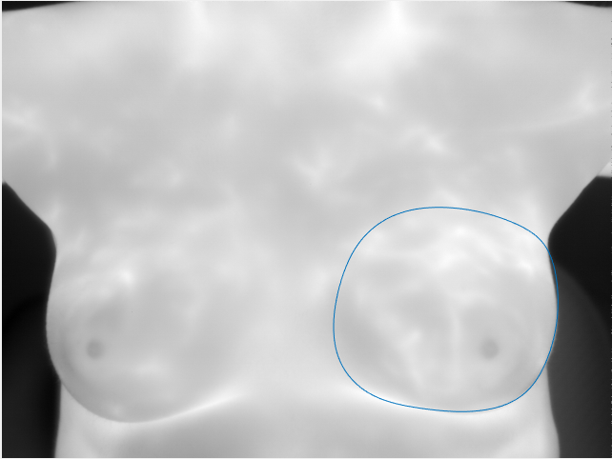

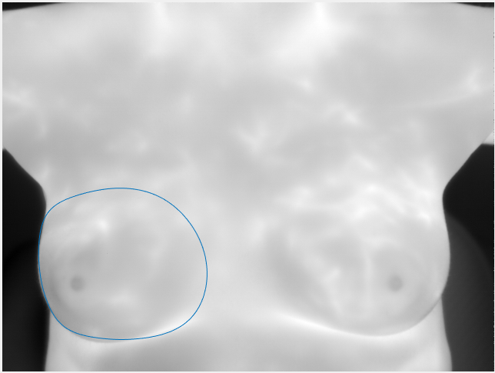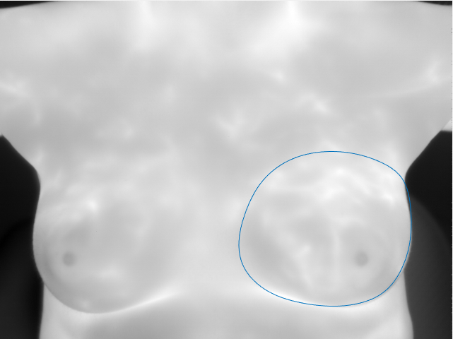

Touching the edge. 9 points

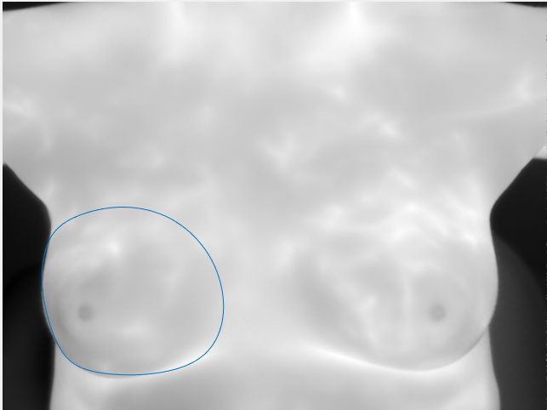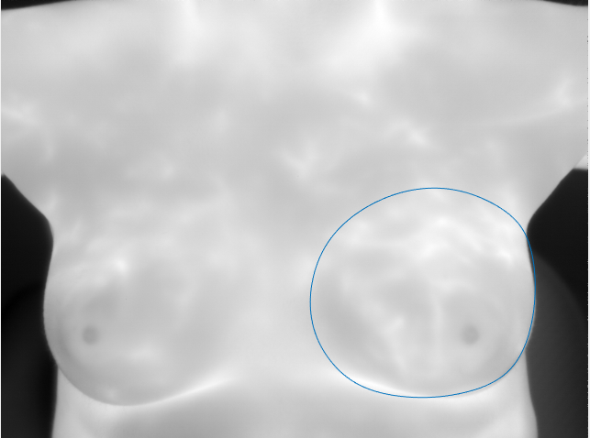

Two Breasts.

1799 - P1

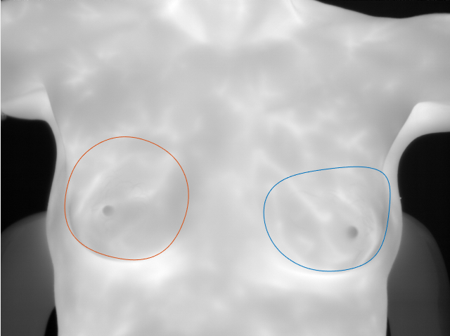

1799 - IRVT001

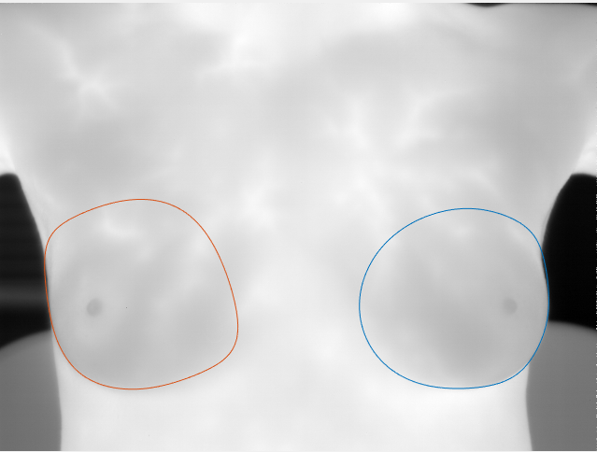

1799 - P3

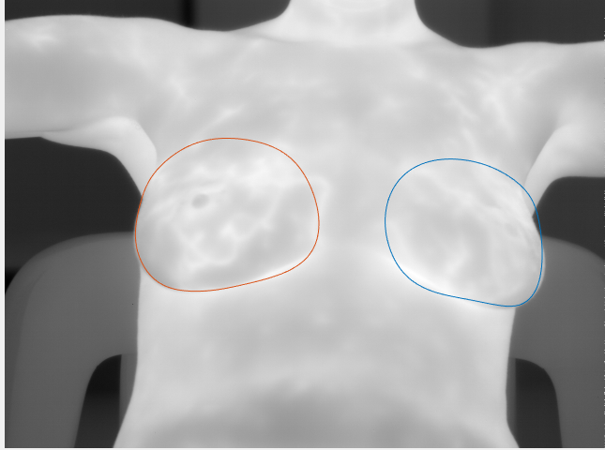

1799 - V10

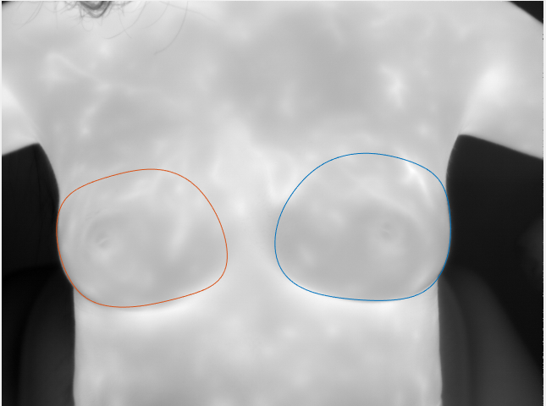

1799 - V10

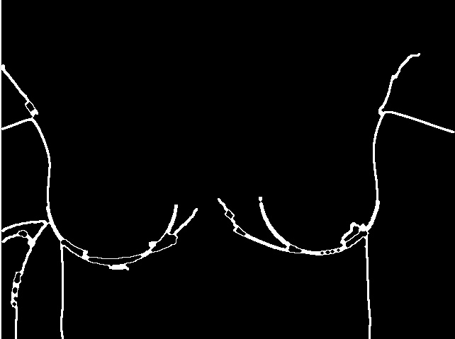

1799 - V11

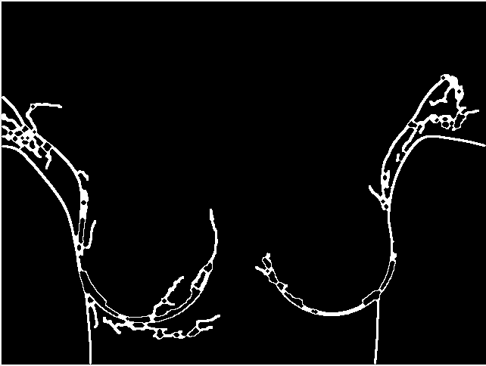

1799 - V4

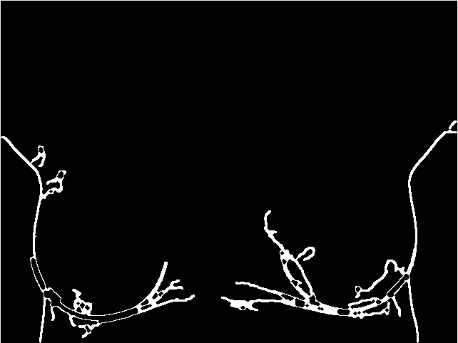

3599 - IRVT301

